# David Crockett Middle School 2025-2026 Course Syllabus

**ELA**

## Instructor: Mrs. Robertson Room: 702

**Email:** [**Tiffanyk.robertson@fortbendisd.gov**](mailto:Tiffanyk.robertson@fortbendisd.gov) **Phone:**

**Conference Days/Times *BY APPOINTMENT*:**

## 2nd period: 9:50-10:40am (M/Th/F) and 9:45-10:30am (T/W)

## 281-329-4957



#### MATERIALS

**Individual Supplies**

Laptop

Headphones or Ear Buds (Optional) Composition Notebook

Folder w/Pockets

Black or Blue Ink Pens

Pencils Highlighters

Pink Pearl Eraser **Classroom Supply** Kleenex

**Wide Rule** Notebook Filler Paper

1 package of disinfecting wipes (bleach- free)

Hand Sanitizer

### Please have individual supplies as soon as possible, but all supplies by 8/19/2025.

#### SCHEDULE

Period 1: 7th Grade ELA

Period 2: PLC/Conference

Period 3: 7th Grade ELA

Period 4: 7th Grade ELA AAC

Period 5: 7th Grade ELA AAC

Period 6: 7th Grade ELA

Period 7: 7th Grade ELA AAC

#### CELL PHONE POLICY

**NO CELLPHONE ZONE!!!**

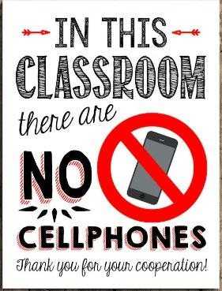

COURSE OBJECTIVES

In 7th Grade English Language Arts, students will read and analyze a variety of literary and informational texts, identifying themes, main ideas, and supporting details. They will learn to support their ideas with strong evidence, write clear and well-organized argumentative, informative, and narrative pieces, and use correct grammar, punctuation, and vocabulary. Students will also participate in discussions and presentations to build speaking and listening skills, conduct research using credible sources, and develop critical thinking by making connections between texts and real-world experiences.

GRADING POLICY

### Weighted Grades:

Major Grades: Test/Projects – 50%

Daily Grades: Quizzes/Notebook/Classwork – 50%

GRADING PERIOD

### Term 1 Grading Period (August 12 – October 10, 2025)

Progress Report 1 (August 29)

Progress Report 2 (September 19)

### Term 2 Grading Period (October 21 – December 19, 2025)

Progress Report 3 (November 7)

Progress Report 4 (December 5)

### Term 3 Grading Period (January 8 – March 13, 2026)

Progress Report 5 (January 28)

Progress Report 6 (February 19)

### Term 4 Grading Period (March 23 – May 28, 2026)

Progress Report 7 (April 10)

Progress Report 8 (May 1)

#### MAKE- UP WORK POLICY

It is the student’s responsibility to ask the teacher for make-up work immediately upon returning to school from an absence. Generally, one day for each day of excused absence will be provided for the make-up work. If a test was scheduled before the student was absent, then the student may be required to take the test the day he/she returns.

#### LATE WORK POLICY

Students will be allowed to submit late work. There will be a **10-point** reduction on the grade for each day the assignment is late.

Stay focused.

EXPECTATIONS

•

* **Have a growth mindset…Daily!**
* Come to class prepared and on time.
* Complete **ALL** classroom and homework assignments.
* Respect and be courteous towards your peers and teachers.

#### CLASSROOM ETIQUETTE

### Laptop: Laptops are to be used for classwork only. Stay on approved websites, follow teacher instructions, and keep devices charged and ready for learning. No gaming, messaging, or unrelated browsing during class. Misuse may result in loss of laptop privileges.

### Do not bring food or drinks to class.

#### **Plagiarism:** Copying any part of your work from another student or a published source without proper credit will result in a grade of zero. Plagiarism is easy to detect, so don’t risk it. Focus on expressing your own ideas, you have great one’s worth sharing.

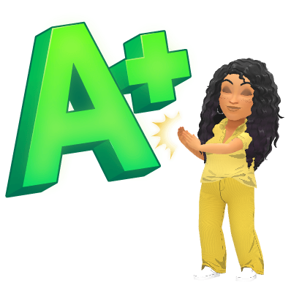

# Please return this information sheet to Mr. Choudhury, by Tuesday, August 19, 2025.

Printed Student Name: Printed Parent/Guardian Name: Class Period:

We have reviewed the course syllabus for 7th Grade ELA.

Student Signature Parent/Guardian Signature Date

Contact numbers where parent/guardian can be reached:

Primary

Alternate

Parent Email Address 1: Parent Email Address 2:

Please provide any additional information you would like me to know about your scholar below.